Merge Command

- Conditionally insert or update

- Also known as “Upsert”, means Update or Insert

- It is an DML command

- Is ANSI SQL

- *** Suitable for avoiding the Primary key duplication error

- ***** More relevant when we cannot see the existing values for taking decision of Insert or Update.

- No need of “PL/SQL” block for writing the logic!!!

- Can be used for the SAME table. (Logic will be like Self-Join)

- Can also be used with DIFFERENT tables, so that the tables get “Synchronized”!!!

Merge command with single table –

Scenario 1-

create table products
(pname varchar2(20),
cost number,
constraint pk5 primary key (pname)
);

insert into products
values('nuts',300);

Select * from Products;

Since pname is pk so we cannot add a duplicate record of pname.

If there is already a pname existing, then do not add the record but update the old record's cost.
If the pname is not existing, then add the new record.

The below Merge command is of updating cost since nuts is already existing.

merge into products P1
using products P2 on (P2.pname = P1.pname
and P2.pname = 'nuts')
when matched then update set P1.cost = 400
when not matched then insert (P1.pname,P1.cost)
values ('nuts',400);

Select * from Products;

Example of adding a new record by merge statement since
pname is not existing

merge into products P1
using products P2 on (P2.pname = P1.pname
and P2.pname = 'bolts')
when matched then update set P1.cost = 9000
when not matched then insert(P1.pname,P1.cost)
values('bolts',9000);

Select * from Products;

Scenario 1- Example 2

Management of a movie theater (part of chain) has asked how to list all the movies being played at the theater, along with showtimes. The interesting part is the showtime information changes daily for existing movies. Every week new movies are added to the list and existing movies have their showtimes changed.
If we try to insert a new record for movies being added and then update existing records with new movie times, Oracle returns an error as moviename is primary key.

create table movie
(moviename varchar2(30) constraint pk_moviename primary key,
showtime varchar2(30));

insert into movie Values ('Terminator III', '3pm');

insert into movie Values ('Terminator III', '5pm'); -- Oracle returns error

To overcome the above situation, Oracle 9i provides the "merge" command as:
merge into movie M1
using movie M2 on (M2.moviename = M1.moviename and M1.moviename = 'Terminator III')
when matched
then update set M1.showtime = '5pm'
when not matched
then insert (M1.moviename, M1.showtime) values ('Lord of the rings', '3pm');

Select * from movie;

Scenario 2 → Merge command with multiple tables –

There are two tables Sales that has data and Sales_Copy that will get refreshed from sales table.
If a new record is added in the Sales table, then that record should get added in the Sales_Copy table. And if a record is updated in the Sales table, then that change should get reflected in the Sales_Copy table.

drop table sales;

create table sales
(custid char(3),
custname varchar2(20),
product varchar2(30),
installment_amt number);

Insert into Sales values('C1','John', 'Car', 4000);
Insert into Sales values('C2','Smith','Home', 12000);

create table Sales_Copy
as
select * from Sales
where 1=2;

select * from Sales_Copy;

merge into sales_copy c
using sales s
on (c.custid = s.custid)

WHEN MATCHED THEN

UPDATE
set
c.custname = s.custname,
c.product = s.product,
c.installment_amt = s.installment_amt
WHEN NOT MATCHED THEN
Insert (custid, custname, product, installment_amt)
values(s.custid, s.custname,s.product,s.installment_amt);

Note – Do not take custid column in the set clause. The On clause field cannot be updated.

select * from sales_copy;

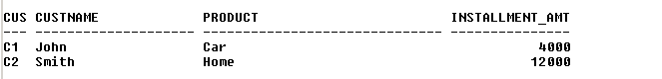

insert into sales values('C3','Roger','Business',8000);

select * from sales;
select * from sales_copy;
-- Not in sync

merge into sales_copy c
using sales s
on (c.custid = s.custid)
WHEN MATCHED THEN UPDATE
set
c.custname = s.custname,
c.product = s.product,
c.installment_amt = s.installment_amt
WHEN NOT MATCHED THEN
Insert (custid, custname, product, installment_amt)
values(s.custid, s.custname,s.product,s.installment_amt);

select * from sales_copy;

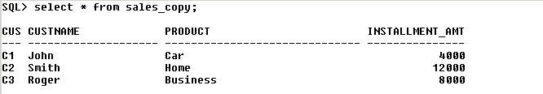
New record of Roger

Now update installment_amt of John in the original table sales

update sales
set installment_amt = 6000
where custname = 'John';

select * from sales;
select * from sales_copy;
-- Not in sync

merge into sales_copy c
using sales s
on (c.custid = s.custid)
WHEN MATCHED THEN UPDATE
set
c.custname = s.custname,
c.product = s.product,
c.installment_amt = s.installment_amt
WHEN NOT MATCHED THEN
Insert (custid, custname, product, installment_amt)
values(s.custid, s.custname,s.product,s.installment_amt);

select * from sales_copy;

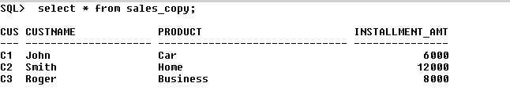
Changed value

